Export Color PDF Combined— Supernote Plugin

A plugin for the Supernote NOTE and DOC apps that Exports colored pen strokes within documents to either a PNG or PDF output.

Plugin also allows user to export only the current page, a specific page range, annotated pages, only new annotations or the entire document. This piece works with non-colored notes and docs.

When viewed on a color screen, the colored strokes appear, even though they do not look colored when adding them via a Supernote.

Currently this plugin only works for NOTE and DOCs. Does not work for Digests.

To activate this plugin:

From either a NOTE or a DOC, click the Plugins Button, then choose “Export Color PDF”.

Choose from the following:

- PDF
- PNG (Image Files)

If you chose PNG, then choose from the following

- One PNG per Page
- One Combined PNG

Please note that combined PNG files are limited to 25 pages.

Then Choose

- Annotated pages only

- Pages with new annotations

3. Entire Document
(Please see note above for Combined PNG limitations)

When the export starts, you will see a notification on the screen about what stage you’re in and/or what page is being exported.

Please note that this plugin now works in either Portrait or Landscape orientation. It will export annotations applied to a Doc or Note regardless of the orientation of the screen at the time.

Example output:

Notes:

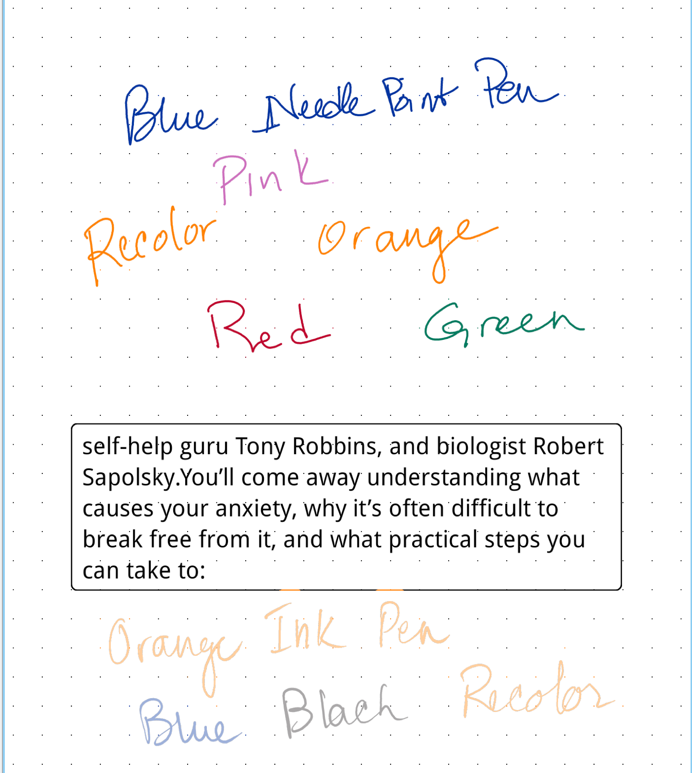

Doc:
Highlighter colors over the headings
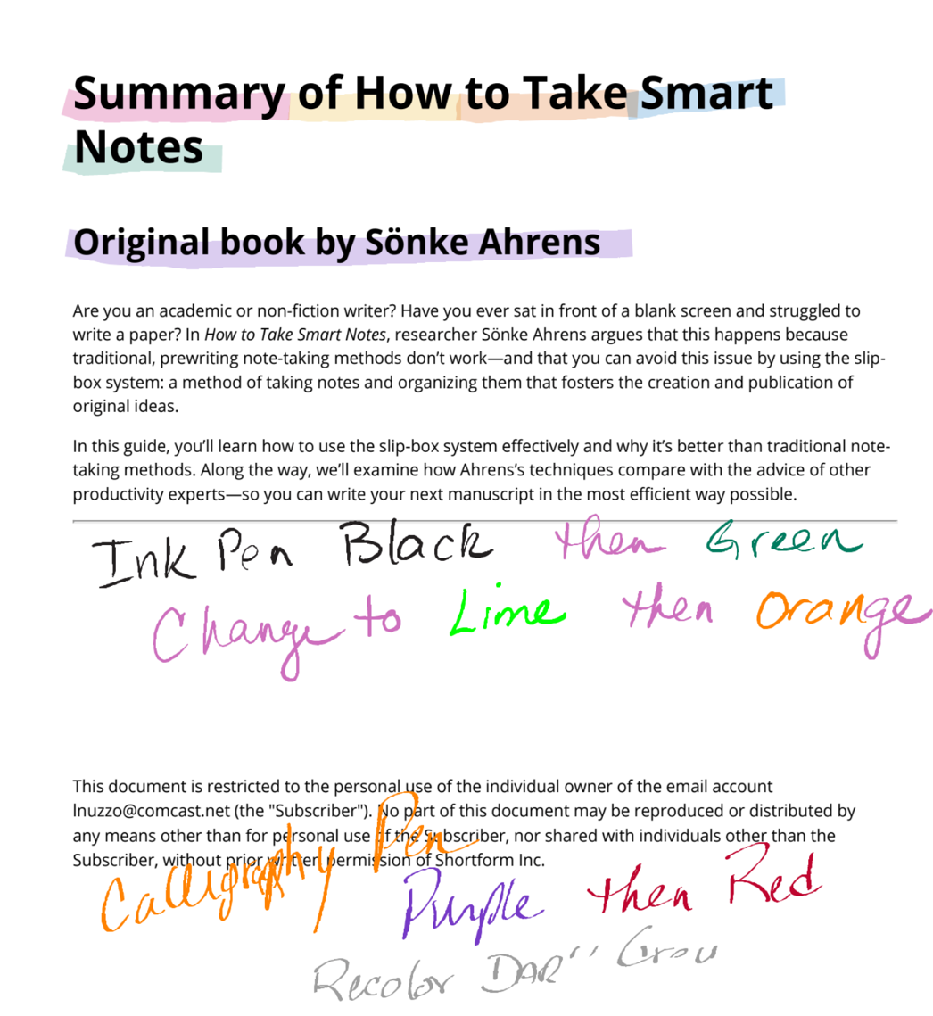
If you don’t completely choose the word with the lasso, only the letters chosen change color

Note with Marker:

